Network Security Plan Analysis

Network Diagram

I have created the network diagram where my host would be 172.16.0.0/16. The reason I use /16 is because it gives me more Ip addresses rather than using /24. I made my router 172.16.1.1 and my DMZ has Ip addresses for the servers. VPN is part of that DMZ so people within the organization have access to the Sweetwater network. Also, I note that my web server also has a public and private ip address. I made sure that the payroll server is close to their department since they have ownership of it. I also placed a firewall for payroll and industrial machines because they hold sensitive data. Also install an IDS for industrial machines so the network team can monitor the machines going in and out of traffic.

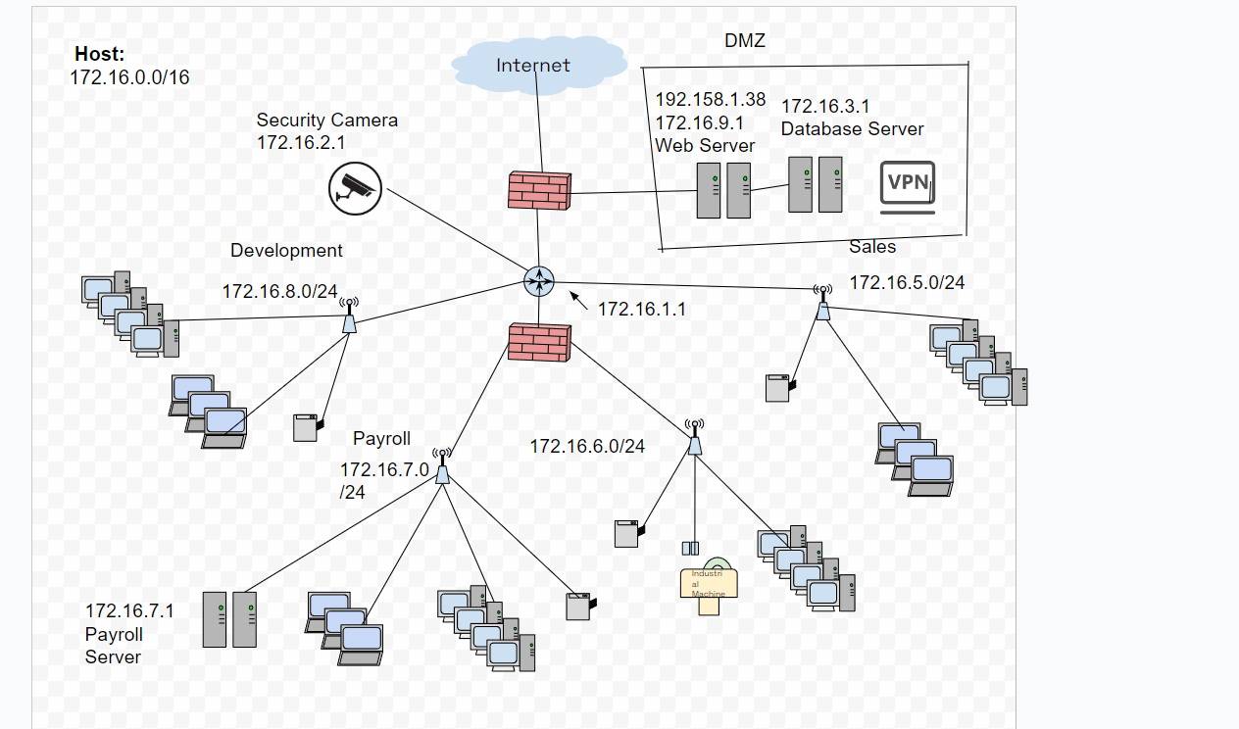

IP Addresses

1. Host: 172.16.0.0/16
2. Router: 172.16.1.1
3. Web Server:
   1. Public: 192.158.1.38
   2. Private:172.16.9.1
4. Database Server: 172.16.3.1
5. Payroll Server: 172.16.7.1
6. 50 Desktops, 30 Printers and 4 Network Printers
   1. Development: 172.16.8.0/24
   2. Payroll: 172.16.7.0/24
   3. 10 Industrial Machine: 172.16.6.0/24
   4. Sales: 172.16.5.0/24
7. Security Camera 172.16.0.0/16

Roles and Responsibilities

* Security Camera- Security Guards
* Printers- IT Team
* Access Point- Network Team
* Servers- Network Team
* Firewall- SOC Team
* IDS- SOC Team
* DMZ- Network Team and SOC Team

Access Point Placements and Printers

The wireless is placed near every corner of the company, so it could have the range for people to have access to the Wi-Fi. 802.11 ac is good for Wireless standard protocol because it gives good range and gives maximum amount of frequency. The others did not provide good frequency with a reliable range. WPA2 was created to be better, faster, and more robust than the original WPA. It’s also got strong encryption when sending traffic. And you need credentials to get into the Sweetwater network. However, I also created a guest Wi-Fi for contractors or people that need to get into the network. The SSID: is SweetWater Guest and the passcode is: SweetW@ter69!!. I placed the printers in Payroll, Sales, Engineering and Development. But reception could use a printer and maybe the factory floor could have its own printer as well.

Firewall Rules

1. Do not respond to ping requests.
2. Reject MySQL requests from the Internet. (database server)
3. Drop all ssh traffic outbound from the web server.
4. Reject any source from the internet to payroll server.
5. Reject any source from the web server.
6. 189.61.4.203 allow for client.
7. 101.99.230.16 allow for client.
8. Security camera reject any from the internet.
9. Reject any Industrial Machine.
10. Reject any FTP
11. Reject any FTP

